Daily Food Record Instructions

The information you record in your daily food record will provide us a detailed account of what you eat each day. Please complete this Daily Food Record for 3 full days. Please try to include at least 1 weekend day (days do not need to be consecutive).

Time: Write the time of day you ate the food.

Food Item: In these columns, write down the type of food you ate or liquid you consumed. Be as specific as you can. Include sauces and gravies. Don't forget to write down "extras," such as salad dressing, mayonnaise, butter, sugar and ketchup. Also include any glasses of water or other drinks consumed.

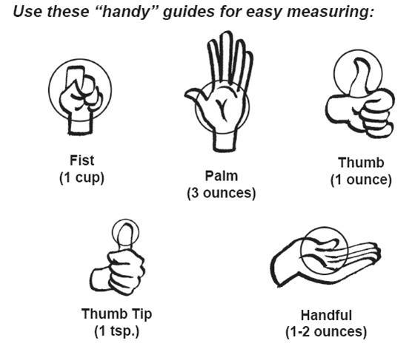
Amount: Record an approximate portion size. Use the guide below to help you estimate.

Description and How Prepared: Include information about the brand of food, the restaurant it was from, and how it was prepared (e.g. baked, fried…).

Helpful Hints:
- Don't change your eating habits while you're keeping your food diary. Just continue to eat as you normally would.
- Tell the truth. We aren’t here to judge your eating habits!

Some basic rules to remember:
Write down everything
Keep your form with you all day, and write down everything you eat or drink. A piece of chocolate or a couple of biscuits may not seem much at the time but they all add up.

Do it now
Don't depend on your memory at the end of the day. Record your eating as you go. You will find an example on the next page.

EXAMPLE Daily Food Record
Name:____Adam Brown_____________________ Day & Date of Intake: Friday 11/03/2016

Meal | Time  Of Day | Food Item | Amount | Description  (Brand or restaurant) | How Prepared  (if applicable)
Breakfast | 8:30am | Cheerios | 1 ½ cup | General Mills
 |  | sugar | 2 tsp
 |  | 2% milk | 1 cup | Purity
 |  | Fresh blueberries | ¾ cup
 |  | Orange juice | ½ cup
 |  | Water | 1 cup
 |  | Fish oil capsules | 2 | NutraLife Fish Oil 1500 mg
Lunch | 12:45pm | Turkey sub | 6 in | Subway
 |  | including shredded lettuce | ¼ cup |  | Shredded
 |  | and tomato | ¼ cup |  | Sliced
 |  | on wheat bread
 |  | with Cheddar Cheese Slices | 2 oz
 |  | with mayonnaise | 1 Tbsp
 |  | Baked Lays Orig. Potato Crisps | 1 oz | Frito-Lay
 |  | Diet Coke | 16 fl oz
Dinner | 7:00pm | Salmon fillet | 5 oz |  | baked
 |  | with Diced Raw Tomato | ½ cup
 |  | and Diced Raw Onion | ½ cup
 |  | and White Wine for Cooking | ½ cup
 |  | and Ground Black Pepper | ¼ tsp
 |  | Long Grain Brown Rice | ¾ cup |  | Cooked
 |  | Salad |  |  | Tossed
 |  | Romaine Lettuce | 2 cups |  | Shredded
 |  | Raw Carrots | 1/3 cup |  | Sliced
 |  | Raw Tomatoes | ½ cup |  | Diced
 |  | with Italian Dressing | 2 Tbsp
 |  | White wine | 5 fl oz
Snacks | 3:00pm | Apple | 1 medium
 |  | Peanut butter | 1 tbsp | Peter Pan creamy
 |  | Bottled water | 12 fl oz
 | 8:00pm | Peanut M and M’s | 10 | Shared pkg with friend
 |  | Water with lemon | 2 cups
 | 10:00pm | Popcorn Light Natural Flavor | 2 cups | Orville | Microwaved
 |  | Green tea | 1 cup

Daily Food Record
Name: ____________________________Day/Date of Intake: _____________________
Meal | Time  Of Day | Food Item | Amount | Description  (Brand or restaurant) | How Prepared  (if applicable)
Breakfast
Lunch
Dinner
Snacks
- Record food items as completely as possible.
- Don’t forget beverages, including alcoholic beverages, sodas, and water.
- Include preparation method or other details that may help describe the food, for example: indicate whether a chicken breast is baked, grilled, breaded, fried, etc. or whether vegetables are raw, steamed, sautéed, fried, etc.
- If you are taking supplements (like fish oil) fill those in as well, and include the amount and brand of supplements taken.

Daily Food Record
Name: ______________________________Day/Date of Intake: ______________________
Meal | Time  Of Day | Food Item | Amount | Description  (Brand or restaurant) | How Prepared  (if applicable)
Breakfast
Lunch
Dinner
Snacks
- Record food items as completely as possible.
- Don’t forget beverages, including alcoholic beverages, sodas, and water.
- Include preparation method or other details that may help describe the food, for example: indicate whether a chicken breast is baked, grilled, breaded, fried, etc. or whether vegetables are raw, steamed, sautéed, fried, etc.
- If you are taking supplements (like fish oil) fill those in as well, and include the amount and brand of supplements taken.

Daily Food Record
Name: _____________________________Day/Date of Intake: ______________________
Meal | Time  Of Day | Food Item | Amount | Description  (Brand or restaurant) | How Prepared  (if applicable)
Breakfast
Lunch
Dinner
Snacks
- Record food items as completely as possible.
- Don’t forget beverages, including alcoholic beverages, sodas, and water.
- Include preparation method or other details that may help describe the food, for example: indicate whether a chicken breast is baked, grilled, breaded, fried, etc. or whether vegetables are raw, steamed, sautéed, fried, etc.
- If you are taking supplements (like fish oil) fill those in as well, and include the amount and brand of supplements taken.

